**TITLE OF LAB: (BINARY SEARCH TREE BST)**

**LAB REPORT NO.10**



**Spring 2022**

**CSE-210L Data Structures and Algorithm Lab**

Submitted by

Name:: **Safi Ullah Khan**

Registration No. **20PWCSE1943**

Class Section: **B**

“On my honor, as student of University of Engineering and Technology, I have neither given nor received unauthorized assistance on this academic work.”

Student Signature: ______________

Submitted to:

**Dr. Khurram Shehzad Khattak**

(Friday, July 29th, 2022)

**Department of Computer Systems Engineering**

**University of Engineering and Technology, Peshawar**

**OBJECTIVES OF THE LAB**

‐‐‐‐‐‐‐‐‐‐‐‐‐‐‐‐‐‐‐‐‐‐‐‐‐‐‐‐‐‐‐‐‐‐‐‐‐‐‐‐‐‐‐‐‐‐‐‐‐‐‐‐‐‐‐‐‐‐‐‐‐‐‐‐‐‐‐‐‐‐‐‐‐‐‐

In this lab, we will implement and perform basic operations on Binary Search Tree Data Structures.

‐‐‐‐‐‐‐‐‐‐‐‐‐‐‐‐‐‐‐‐‐‐‐‐‐‐‐‐‐‐‐‐‐‐‐‐‐‐‐‐‐‐‐‐‐‐‐‐‐‐‐‐‐‐‐‐‐‐‐‐‐‐‐‐‐‐‐‐‐‐‐‐‐‐‐

**Binary Search Tree:**

A BST is a binary tree of nodes ordered in the following way:

1. Each node contains one key (also unique)
2. The keys in the left subtree are < (less) than the key in its parent node
3. The keys in the right subtree > (greater) than the key in its parent node

Duplicate node keys are not allowed.

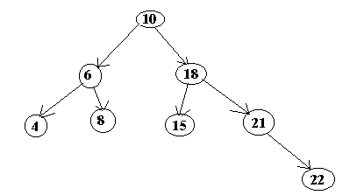

## **Task 01**

**Implement binary search tree with following operations**

1. Creation
2. Insertion
3. Find minimum
4. Find Maximum
5. Delete Element
6. Post order traversal
7. Pre order traversal
8. In order traversal
9. Height of tree

**Screenshot of Input:**

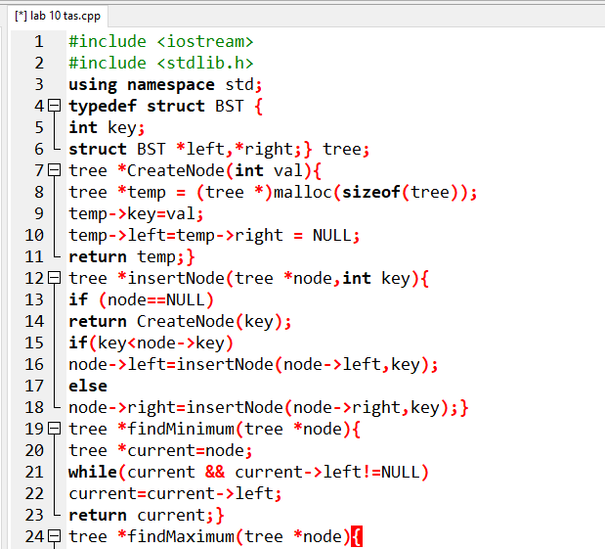

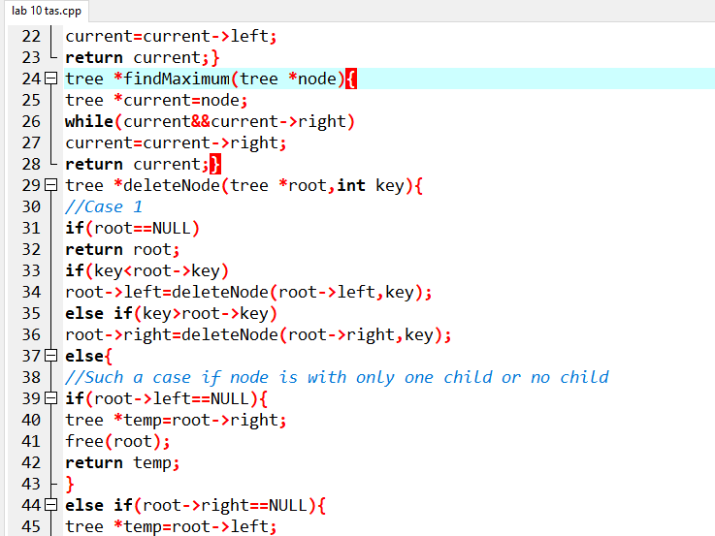

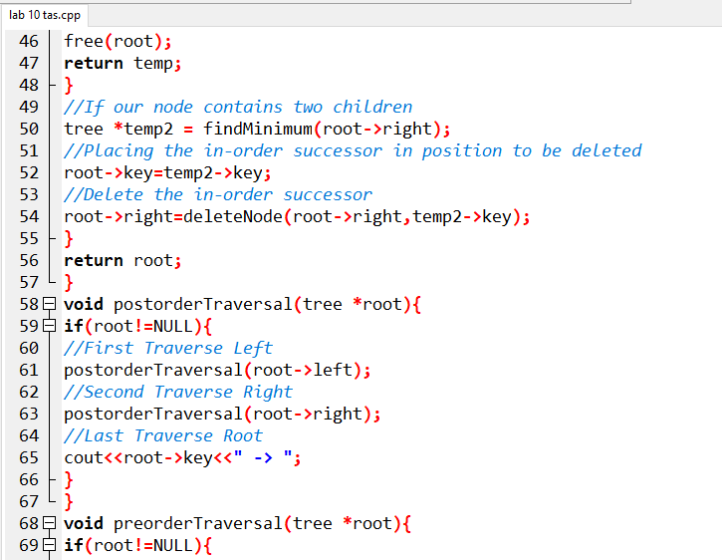

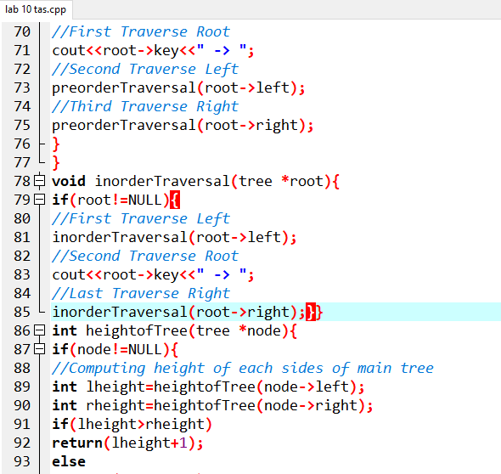

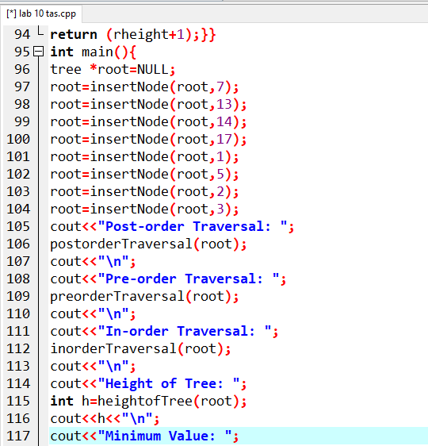

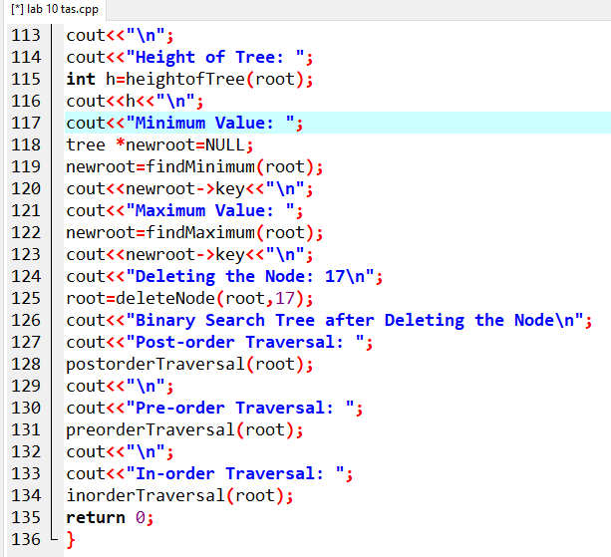

**Screenshot of Output:**

